

PDEA’ S
Mamasaheb Mohol College
(Arts commerce & science)
Paud Road Pune -38

Name of the Department: Computer Science

Academic Calendar: 2021-22

June – 2021

Day | Date | Business of the Day | Remark
Tuesday | 15 | Commencement of first term  Departmental Meeting
Wednesday | 16
Thursday | 17 |  | Jijau Smritidin
Friday | 18
Saturday | 19
Sunday | 20
Monday | 21 |  | International Yoga day
Tuesday | 22
Wednesday | 23
Thursday | 24
Friday | 25
Saturday | 26 |  | Shahu Maharaj Jayanti
Sunday | 27
Monday | 28
Tuesday | 29
Wednesday | 30

July – 2021

Day | Date | Business of the Day |  |  | Remark
Thursday | 1 |  |  |  | Doctor’s Day
Friday | 2 | NAAC Peer Team Visit
Saturday | 3 | NAAC Peer Team Visit
Sunday | 4
Monday | 5
Tuesday | 6
Wednesday | 7
Thursday | 8
Friday | 9
Saturday | 10 |  |  |  | Matrusuraksha din
Sunday | 11 |  |  |  | World Population Day
Monday | 12
Tuesday | 13
Wednesday | 14 |  |  |  | Gopal Ganesh Agarkat Jayanti
Thursday | 15 |  |  |  | S.M Jagtap Jayanti
Friday | 16
Saturday | 17 |  |  |  | Sevak Sahakari Patsanstha Vardhapan Din
Sunday | 18 |  |  |  | KakasahebBhelkePunyatithi  Anna Bhau Sathe Smutidin  Sant Namdev Smritidin
Monday | 19
Tuesday | 20 | Hon. Ajit dada Pawar  Birth day celebration week |  |  | Aashadhi Ekadashi  Maharashtra Krishidin
Wednesday | 21 | Bakari Eid Holiday
Thursday | 22 |  |  |  | Hon. Ajit dada Pawar  Birth day
Friday | 23 |  |  |  | Lokmanya Tilak Jayanti  Van Samvardhan Din  Gurupournima
Saturday | 24
Sunday | 25
Monday | 26
Tuesday | 27 | Departmental Meeting
Wednesday | 28
Thursday | 29
Friday | 30
Saturday | 31 |  |  |  | Rajaram Maharaj Jayanti

August – 2021

Day | Date | Business of the Day |  |  | Remark
Sunday | 1 |  |  |  | Lokmanya Tilak Punyatithi  Appasaheb Bandal Punyatithi  Anna Bhau Sathe Jayanti
Monday | 2 | - F.Y.B.Sc Student Interaction On CBCS
Tuesday | 3
Wednesday | 4
Thursday | 5
Friday | 6
Saturday | 7
Sunday | 8
Monday | 9 |  |  |  | August Kranti Din  World Tribal Day
Tuesday | 10
Wednesday | 11
Thursday | 12 |  |  |  | SantNamdevPunyatithi
Friday | 13 |  |  |  | Shardabai Pawar Punnyasmaran  Ahilyabai Holkar punyadin  Nagpanchami
Saturday | 14
Sunday | 15 | National festival celebration |  |  | Independence Day  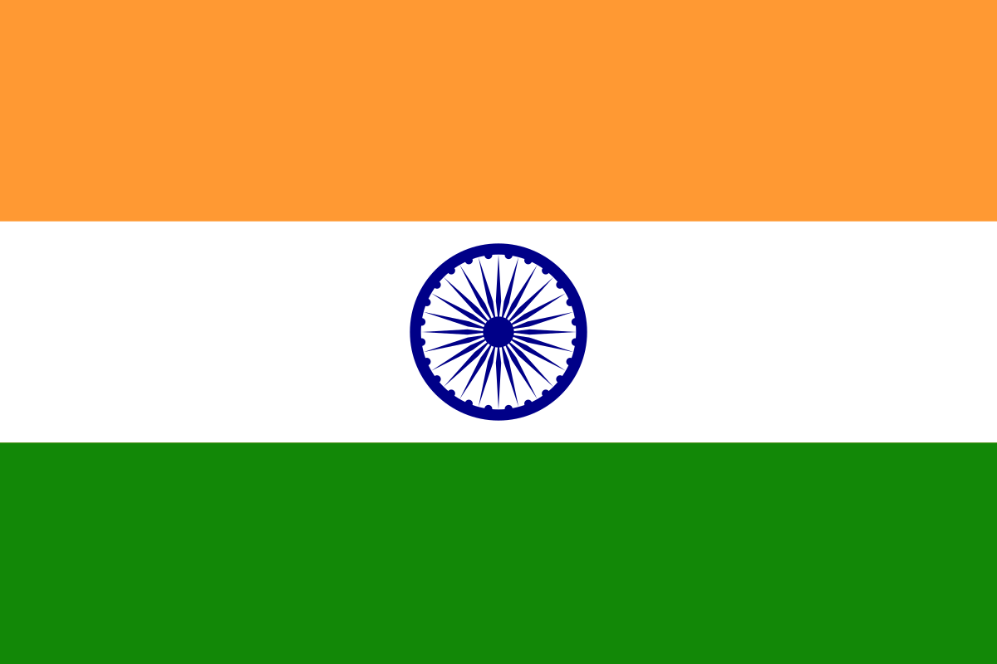
Monday | 16 |  |  |  | Parshi New Year
Tuesday | 17
Wednesday | 18
Thursday | 19 |  |  |  | Mamasaheb Pimpale  Punyatithi  Moharum
Friday | 20
Saturday | 21
Sunday | 22 |  |  |  | Naralipornima  Rakshabandhan
Monday | 23
Tuesday | 24
Wednesday | 25
Thursday | 26
Friday | 27 |  |  |  | S M JagtapPunyatithi
Saturday | 28
Sunday | 29 |  |  |  | AhilyadeviHolkarPunyatithi,  National Sports Day
Monday | 30
Tuesday | 31 | DiagnosticTest for FY./S.Y.B.Sc. |  |  | Gokulashtami
September – 2021

Day | Date | Business of the Day | Remark
Wednesday | 1
Thursday | 2
Friday | 3
Saturday | 4
Sunday | 5 |  | Teacher’s Day  Dr Radhakrishnan Birth anniversary
Monday | 6 | Addon Course Start for F.Y/S.Y/T.Y B.C.S students
Tuesday | 7 |  | PDEA Vardhapan din  
Wednesday | 8
Thursday | 9 | F.Y.B.Sc Student Interaction  (Dialogue Bridge with students by Principal )
Friday | 10 | Holiday | Shankarrao Ursal Jayanti  Ganesh Chaturthi
Saturday | 11
Sunday | 12
Monday | 13 |  | Gauri Pujan
Tuesday | 14 |  | Hindi Din  Munshi Premchand Jayanti
Wednesday | 15 |  | Engineer’s Day  Vishveshwaraiyya Jayanti
Thursday | 16
Friday | 17 |  | Marathwada Mukti Din
Saturday | 18
Sunday | 19 |  | Anant Chaturdashi
Monday | 20
Tuesday | 21
Wednesday | 22 |  | Equator Day
Thursday | 23
Friday | 24 |  | Heart Disease Awareness Day
Saturday | 25
Sunday | 26
Monday | 27 | Departmental Meeting
Tuesday | 28 |  | KarnaBadhir Din
Wednesday | 29
Thursday | 30

October – 2021

Day | Date | Business of the Day | Remark
Friday | 1
Saturday | 2 | Holiday | Gandhi Jayanti & LalBhadur Shastri Jayanti
Sunday | 3
Monday | 4 | M.Sc.(CS) I,II Assignment  submission
Tuesday | 5 |  | AnnasahebWaghireJayanti
Wednesday | 6
Thursday | 7 |  | Wild Animal Day  Ghatsthapana
Friday | 8
Saturday | 9 | Parent Meet | Tapal Din
Sunday | 10
Monday | 11
Tuesday | 12
Wednesday | 13
Thursday | 14 | Reading Inspiration Day
Friday | 15 | Dasara Holiday | APJ Abdul Kalam’s Birth Anniversary  Vachan Prerana Din  World’s Blind Assistance Day,
Saturday | 16
Sunday | 17
Monday | 18 | Internal Exams for UG (Computer  Sci. dept.)(4days) B.Sc.)
Tuesday | 19 |  | Kojagiri Pournima  Eid –E-Milad
Wednesday | 20
Thursday | 21
Friday | 22
Saturday | 23 | Departmental Meeting
Sunday | 24
Monday | 25 | F.Y. B.Sc. Practical exam (CBCS) (Comp. Sci. Dept.)
Tuesday | 26 | M.Sc. I st / II nd year Seminar (Comp. Sci. Dept.)
Wednesday | 27
Thursday | 28
Friday | 29
Saturday | 30
Sunday | 31

November – 2021

Day | Date | Business of the Day | Remark
Monday | 1 |  | Dd  JJ
Tuesday | 2
Wednesday | 3
Thursday | 4 | Deepavali Laxmipujan Holiday
Friday | 5 | Deepavali Padava Holiday | SSSant Tukadoji Maharaj Punyatithi  Marathi Rangbhumi din
Saturday | 6
Sunday | 7
Monday | 8
Tuesday | 9
Wednesday | 10
Thursday | 11
Friday | 12
Saturday | 13
Sunday | 14 |  | Pandit Nehru Jayanti,  Bal Din
Monday | 15
Tuesday | 16
Wednesday | 17
Thursday | 18
Friday | 19 | Holiday  Gurunanak Jayanti | Indira Gandhiji Jayanti
Saturday | 20 |  | AnnasahebAwatePunyatithi
Sunday | 21
Monday | 22
Tuesday | 23
Wednesday | 24
Thursday | 25
Friday | 26 |  | Constitution Day
Saturday | 27
Sunday | 28 |  | Joytiba Phule Punyatithi
Monday | 29
Tuesday | 30

December– 2021

Day | Date | Business of the Day | Remark
Wednesday | 1 |  | AIDS Nirmulan Din
Thursday | 2
Friday | 3 |  | JagtikApanga Din
Saturday | 4
Sunday | 5
Monday | 6 |  | Dr.AmbedkarPunyatithi MamasahebMoholPunyatithi
Tuesday | 7 | Departmental Workshop Under BOD | Flag Day
Wednesday | 8
Thursday | 9
Friday | 10 |  | Human Rights Day
Saturday | 11 | Poster and Project Competition on the occasions of Birthday of  Hon. Sharadchandraji Pawar Saheb
Sunday | 12 |  | Hon..Sharadchandraji  Pawar Birhday  Swadeshi Din
Monday | 13 |  | Pratibha tai pawar Birthday
Tuesday | 14
Wednesday | 15
Thursday | 16
Friday | 17 |  | Pensioner’s Day
Saturday | 18
Sunday | 19
Monday | 20 |  | GadgebabaPunyatithi
Tuesday | 21 |  | ShankarraoUrsalPunyatithi  Shivapratap Din
Wednesday | 22 | Mathematics PPT/Poster Presentation
Thursday | 23 | Statistics Quiz | Kisan Din
Friday | 24 |  | Grahak Din
Saturday | 25 | CHRISMAS Holiday
Sunday | 26
Monday | 27
Tuesday | 28
Wednesday | 29
Thursday | 30
Friday | 31

January – 2022

Day | Date | Business of the Day | Remark
Saturday | 1
Sunday | 2
Monday | 3 |  | Saviribai Phule Jayanti, Balika Din  Mahila Mukti Din
Tuesday | 4
Wednesday | 5
Thursday | 6 |  | Patrakar Din
Friday | 7
Saturday | 8
Sunday | 9
Monday | 10
Tuesday | 11 |  | LalBahadur Shastri  Punyatithi
Wednesday | 12 |  | Vivekanand Jayanti, RajmataJijauJyanti  National Youth Day
Thursday | 13
Friday | 14
Saturday | 15
Sunday | 16
Monday | 17
Tuesday | 18
Wednesday | 19
Thursday | 20
Friday | 21
Saturday | 22 | Parent Meet
Sunday | 23 |  | Netaji Jayanti
Monday | 24
Tuesday | 25
Wednesday | 26 | National festival celebration | Republic Day
Thursday | 27
Friday | 28
Saturday | 29 |  | AnnasahebAwateJayanti
Sunday | 30 |  | Mahatma Gandhi Punya Din
Monday | 31 | Departmental Meeting

February – 2022

Day | Date | Business of the Day | Remark
Tuesday | 1 |  | Baburaoji Gholap Jayanti
Wednesday | 2
Thursday | 3
Friday | 4
Saturday | 5 | Alumni Lecture Session | MamasahebMoholJayanti
Sunday | 6
Monday | 7
Tuesday | 8
Wednesday | 9
Thursday | 10
Friday | 11
Saturday | 12 | Departmental Meeting
Sunday | 13
Monday | 14
Tuesday | 15 |  | Sevalal Maharaj Jayanti
Wednesday | 16 | Internal Exams for UG
Thursday | 17 |  | Lahuji Salave Punyatithi
Friday | 18
Saturday | 19 |  | Chhatrapati Shivaji Maharaj  Jayanti
Sunday | 20
Monday | 21 |  | Sant Gadge Maharaj Jayanti
Tuesday | 22
Wednesday | 23 | FY/SY/ Assignment  Submission
Thursday | 24 |  | World Printing Day
Friday | 25
Saturday | 26 | Departmental Meeting | SwatantryaveerSavarkarPunyatithi
Sunday | 27 |  | Marathi Rajyabhasha Din  Kusumagraj Jayanti
Monday | 28 |  | National Science Day

March 2022

Day | Date | Business of the Day | Remark
Tuesday | 1 | M.Sc. I st / II nd year Seminar
Wednesday | 2
Thursday | 3 |  | Mamasaheb Pimple Jayanti  Rajiv sethSabaleJyanti
Friday | 4
Saturday | 5
Sunday | 6
Monday | 7
Tuesday | 8 |  | Women’s day
Wednesday | 9 | M.Sc. I st /II nd year Assignment  Submission
Thursday | 10 |  | SavitribaiPhulePunyadin
Friday | 11 |  | SambhajiRajeBalidan Din
Saturday | 12 |  | Yashvantrao Chavan Jayanti
Sunday | 13
Monday | 14
Tuesday | 15 |  | World Consumer Day
Wednesday | 16
Thursday | 17 | SPPU University Backlog Exam SY/TY/B.Sc.Computer science
Friday | 18
Saturday | 19
Sunday | 20 |  | Equator Day
Monday | 21 | F.Y.B.Sc. Practical Exam
Tuesday | 22 |  | World Water DAY
Wednesday | 23 |  | World Weather Day
Thursday | 24
Friday | 25 | Departmental Meeting
Saturday | 26 |  | Sant Zulelal Jayanti
Sunday | 27
Monday | 28 |  | AppasoBandalJayanti
Tuesday | 29
Wednesday | 30
Thursday | 31

April – 2022

Day | Date | Business of the Day | Remark
Friday | 1 | M.Sc. Ist and II^{n} year Internal Exam
Saturday | 2
Sunday | 3
Monday | 4 | SPPU University Exam FY/SY/TY/B.Sc.Computer science
Tuesday | 5
Wednesday | 6
Thursday | 7 |  | World Health Day
Friday | 8
Saturday | 9
Sunday | 10
Monday | 11 |  | Mahatma PhuleJayanti
Tuesday | 12
Wednesday | 13 |  | Jaliyan wala Baug Smriti
Thursday | 14 |  | Dr. Babasaheb AmbedkarJayanti
Friday | 15
Saturday | 16
Sunday | 17
Monday | 18 | Departmental Meeting
Tuesday | 19
Wednesday | 20
Thursday | 21
Friday | 22 |  | Earth Day
Saturday | 23
Sunday | 24 |  | Jalsampatti Din
Monday | 25
Tuesday | 26
Wednesday | 27
Thursday | 28
Friday | 29
Saturday | 30 |  | TukadojiMaharajJayanti

May – 2022

Day | Date | Business of the Day | Remark
Sunday | 1 |  | Maharashtra Day
Monday | 2 | M.Sc.(Comp.Sci) Semester Uni. Exam
Tuesday | 3 | M.Sc.(Comp.Sci) Semester Uni. Exam
Wednesday | 4 | M.Sc.(Comp.Sci) Semester Uni. Exam
Thursday | 5 | M.Sc.(Comp.Sci) Semester Uni. Exam
Friday | 6 | M.Sc.(Comp.Sci) Semester Uni. Exam
Saturday | 7 | M.Sc.(Comp.Sci) Semester Uni. Exam
Sunday | 8
Monday | 9 | M.Sc.(Comp.Sci) Semester Uni. Exam
Tuesday | 10 | M.Sc.(Comp.Sci) Semester Uni. Exam
Wednesday | 11 | M.Sc.(Comp.Sci) Semester Uni. Exam | Technology Day
Thursday | 12 | M.Sc.(Comp.Sci) Semester Uni. Exam | Nurse Day
Friday | 13 | M.Sc.(Comp.Sci) Semester Uni. Exam
Saturday | 14 | M.Sc.(Comp.Sci) Semester Uni. Exam
Sunday | 15
Monday | 16
Tuesday | 17
Wednesday | 18
Thursday | 19
Friday | 20
Saturday | 21
Sunday | 22
Monday | 23
Tuesday | 24
Wednesday | 25
Thursday | 26
Friday | 27
Saturday | 28
Sunday | 29
Monday | 30
Tuesday | 31 |  | Ahilyabai Holkar Jayanti

